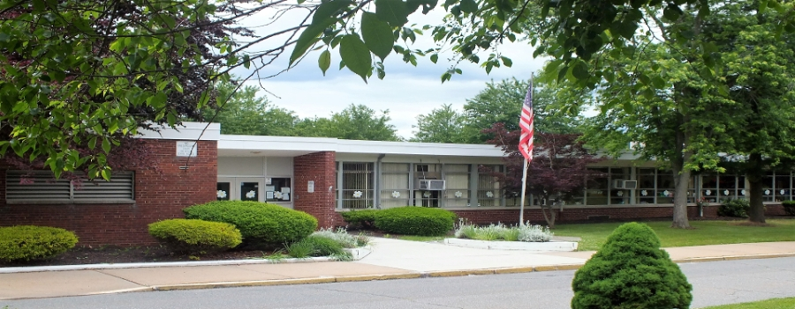  AuGust 29, 2017  KENNeDY SCHOOL OPEN HOUSE  Open House Description  Please join us to begin the transition back to our caring, safe, and nurturing school. This open house will benefit you and your child. Meet some of our faculty, see our classrooms, tour our school, and see all of the wonderful updates for the upcoming school year. All students and parents are welcome to attend this informal event. Light refreshments will be provided by our Parent/Student/Teacher Organization (PTSO).  For more information about our open house, please contact Mr. Hajduk at 908-754-4620 ext. 331. | All students and parents are welcome!  ────  Learn about the upcoming school year events!  ────  See your friends before the first day of school!  ────  This is an informal event that begins at 9:00 AM  John F. Kennedy Elementary School  2900 Norwood Avenue South Plainfield, NJ  908-754-4620 ext. 330  http://spboekes.ss13.sharpschool.com/  Tuesday, August 29, 2017 9:00 AM – 10:00 AM

