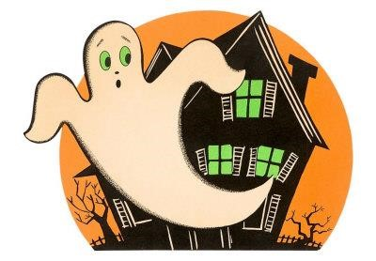
It’s Time for Kennedy School’s Annual Trunk-or-Treat Event!

Friday October 26th, 6-8 PM
Kennedy School Parking Lot

Food, Candy, Ghouls, Ghosts and DJ Che’!

Only $5 Per Child for the Trunk-or-Treating. Open to all Family and Friends!
Why Cook? Picnic Food Available for Purchase on site.

Volunteers! Volunteers! Volunteers!
First and Foremost, we need your Cars! Decorations can be as simple or complex as you want!

We also need some Parents to help run the event…
Set Up, Preparing & Serving, Food, Event Assistance, Clean up…

Can’t volunteer? WE NEED CANDY! The more the better! We will also be offering non-candy treats as well at every Trunk again!

Please contact Scott Miller (as soon as possible) at 732-882-9912 or jedimasterskip@comcast.net to lend a hand.
___________________________________________________________________

Student Name: __________________________ Teacher: ______________________

Total Number Children Attending: __________ Amount Enclosed: _______________

Please Volunteer to Assist us! Provide Phone: ________________________________

Email Address: _________________________________________________________

Check any area you can help with below:
- I’ll decorate my trunk
- I can help set up/clean up
- I can help prepare/serve food
- I can bring baked goods for dessert table
- I will send in candy or treats

Return this Portion by Friday October 19th.

