**Box Tops for Education**

* **DOWNLOAD** the NEW Box Tops app and select our school – Old Post Road Elementary
* **DOWNLOAD** the NEW Box Tops for Education app, complete your profile, and select our school – John F. Kennedy Elementary.
* **SHOP** for Box Tops products and scan your receipt within 14 days in the app to instantly add cash to our school’s earnings online.
* **LOOK** for any physical Box Tops clips. Clip them and send them to school in baggies/envelopes.

**TIP:** You can "double-dip" on these products by clipping the traditional Box Tops AND scanning your store receipt with the app!

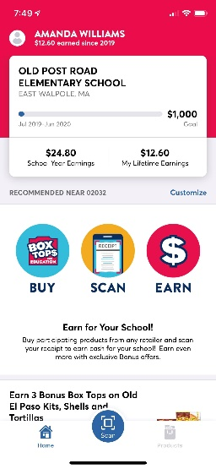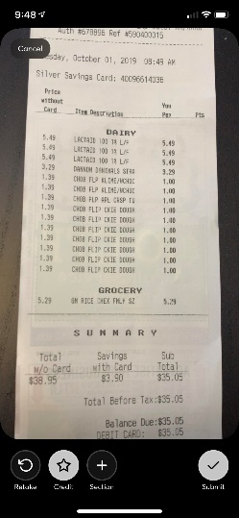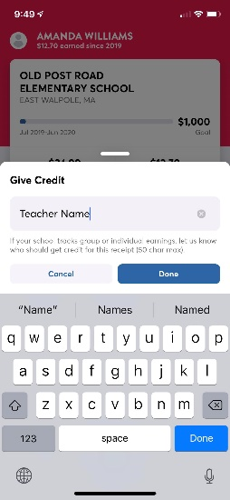

To assign credit:

1. Open app and click scan
2. Scan receipt adding sections if needed
3. Click the “Credit” star
4. Enter Child’s First Name Last Name-Teacher’s

Name and click “Done”

1. Click “Submit”

To assign credit to already scanned receipts:

1. 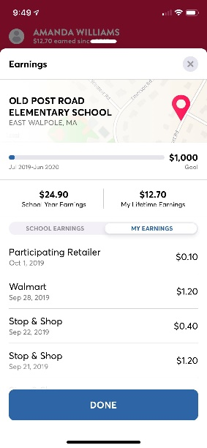From the main screen, click “My Earnings”
2. 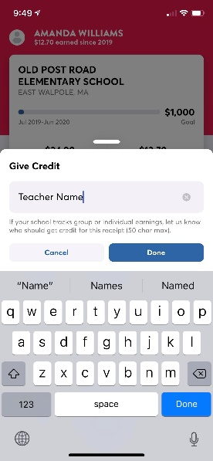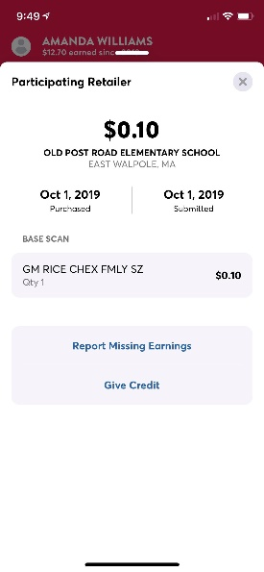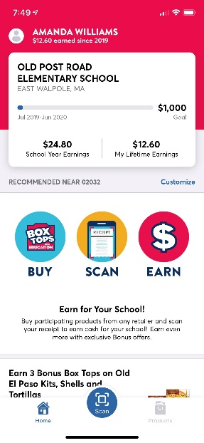Select a past earning
3. Click “Give Credit”
4. Enter Child’s First Name Last Name-

Teacher’s Name and click “Done”